***Preface: How to use the following template***

*This template has been developed within the framework of Challenge 2.2 of the* [*Roadmap of Carcinogens*](https://roadmaponcarcinogens.eu/)*. The purpose of this template is to easily create control guidance sheets (CGS). It combines style content elements to appeal the reader and highlights important information. Furthermore, it provides a general structure with suggestions for headlines. This template should be used by industry associations, institutions and authorities with knowledge on the risks and the prevention measures for a certain task where carcinogens occur.*

*Please fill the template with the required specific information as indicated to make it a CGS addressing employers. When doing so, consider that the CGS should assists employers in implementing suitable preventive measures. This CGS needs to be generic, i.e. be applicable to many workplaces and companies. The employer using the CGS needs to be able to adapt the measures to the actual workplace in his/her company. The employer should also find some hints in the CGS about training and instruction for the employees. In this section, it should be very clear which information the employer needs to pass down to the employees in a way tailored to their needs. The CGS is not supposed to address employees directly or replace written operating instructions.*

*When making a CGS, please delete this preface and use the template only.*

# Introduction

Briefly describe what this Control Guidance Sheet (CGS) covers. Specify substances or group of substances (e.g. silica, asbestos, pesticides), tasks (e.g. drilling, cutting, recycling) or sectors (e.g. construction sector). The title should reflect the scope, e.g. drilling and boring through textured coatings in the presence of asbestos. If there is a series with several CGS, describe which CGS need to be used in addition to this CGS. Some information about possible risks, e.g. for vulnerable groups, might be added. For the measures described below, make sure to use short sentences, clear affirmative language, imperative writing style and a minimum font size of 12 pt. A CGS should not be longer than 3 pages.

# Preparing/Equipment

* Add here what is needed to perform the task in a safe way, for example which tools, systems or exhausts should be used.
* …

# Procedure

* Describe step by step how to perform the task and what preventive measures must be followed.
* Be aware that the measures listed here need to be generic. The employer needs to be able to adapt them to the actual task and workplace at the enterprise.
* 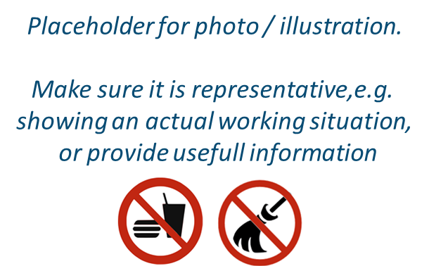…

# Cleaning and maintenance

* Describe step by step how to perform the cleaning and/or maintenance and what preventive and protective measures should be complied with.
* It is helpful for the employer to find important legal obligations here, e.g. intervals for efficiency control, maintenance and servicing.
* ...

|  |
| --- |
| **Very important!** |
| **Very important information should be highlighted in a textbox. Especially important are preventable, reoccurring accidents and their effects, for example:**   * Contamination of organic peroxides might result in an explosion; * In case of skin contact with some substances water should not be used, as the reaction with it might lead to severe injuries; * Neglect of personal hygiene measures when working with lead might result in increased ingestion and cross-contamination. |

# Personal Protective Equipment (PPE)

* Follow the STOP-principle.
* PPE should be avoided, as much as possible. If not possible, consider their use, alone and/or in complement with the other measures in place in the workplace. Provide information regarding which PPE should be used.
* …

# Training and instruction

* Describe what the employer needs to pass down to the employees performing the task in verbal or written operating instructions.
* …

# Additional Information

* List additional aids here which provide further useful information. They might specify certain aspects listed in this CGS in more detail, e.g. how to use specified PSA correctly.

|  |
| --- |
| Notes |
| *[Employer can insert his/her notes here, please delete this explanation]* |