# Introduction

Briefly describe what this Control Guidance Sheet (CGS) covers. Specify substances or group of substances (e.g. silica, asbestos, pesticides), tasks (e.g. drilling, cutting, recycling) at your workplace. The title should reflect the scope, e.g. drilling and boring through textured coatings in the presence of asbestos. If there is a series with several CGS, describe which CGS needs to be used in addition to this CGS. Some information about possible risks, e.g. for vulnerable groups, might be added. For the measures described below, make sure to use short sentences, clear affirmative language, imperative writing style and a minimum font size of 12 pt. A CGS should not be longer than three pages.

# Preparing/equipment

* Add here what is needed to perform the task in a safe way, for example which tools, systems or exhausts should be used.
* …

# Procedure

* Describe step by step how to perform the task and what preventive measures must be followed.
* Be aware that the measures listed here need to be specific for the actual task and workplace at the enterprise.
* 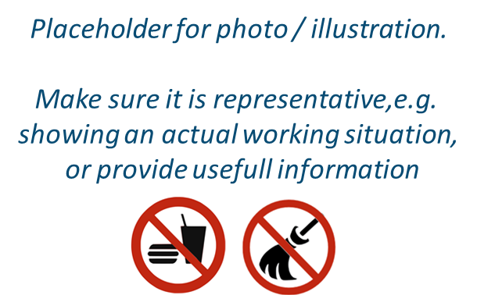…

# Cleaning and maintenance

* Describe step by step how to perform the cleaning and/or maintenance and what preventive and protective measures should be complied with.

# Personal Protective Equipment (PPE)

* Follow the STOP principle.
* PPE should be avoided, as much as possible. If not possible, consider their use, alone and/or in complement with the other measures in place in the workplace. Provide information regarding which PPE should be used.
* …

|  |
| --- |
| **Very important!** |
| **Very important information should be highlighted in a textbox. Especially important are preventable, reoccurring accidents and their effects, for example:**   * Contamination of organic peroxides might result in an explosion; * In case of skin contact with some substances water should not be used, as the reaction with it might lead to severe injuries; * Neglect of personal hygiene measures when working with lead might result in increased ingestion and cross-contamination. |

# Training and instruction

* Describe what you need to pass down to the employees performing the task in verbal and/or written operating instructions.
* …

# Additional information

* List additional aids here, which provide further useful information. They might specify certain aspects listed in this CGS in more detail, e.g. how to use specified PPE correctly.

|  |
| --- |
| Notes |
| Insert your notes here, e.g. other information relevant for your specific workplace. |